BRIEF PROFILE OF PRIYANKA BHARDWAJ
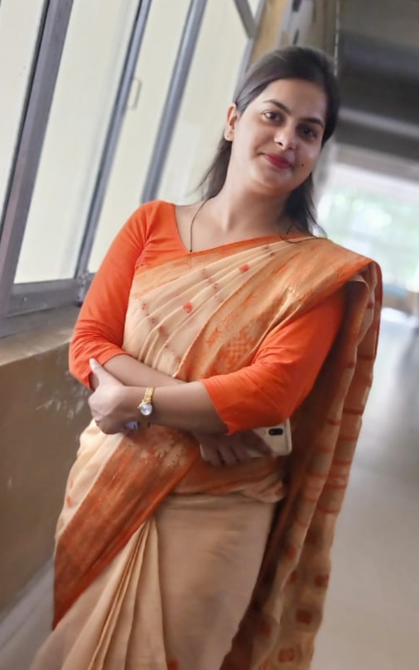
PRIYANKA BHARDWAJ IS A LECTURER AT GOVT. POLYTECHNIC BARGARH , CHITRAKOOT . HER AREA OF SPECIALISATION IS ENGLISH. SHE HAS PURSUED M. A. (ENGLISH) FROM DR. BHIM RAO AMBEDKAR UNIVERSITY, AGRA IN 2012 AND B.ED FROM THE SAME UNIVERSITY IN 2013. SHE HAS AN ACADEMIC EXPERIENCE OF 5 YEARS IN CONVENT SCHOOL .
SHE IS WARM AND CARING TEACHER WHO WANTS ALL CHILDREN TO BE SUCCESSFUL LEARNERS AND WORKS TO CREATE A CLASSROOM ATMOSPHERE THAT IS STIMULATING , ENCOURAGING , AND ADAPTIVE TO THE VARIED NEEDS OF STUDENTS.
SHE HAS EXCEPTIONAL ABILITY TO ESTABLISH COOPERATIVE , PROFESSIONAL, RELATIONSHIPS WITH PARENTS, STAFF AND ADMINISTRATION.

